Introduction:

Customer segmentation is a technique of dividing the customers into groups depending on their age, location, spending history etc. for the purpose of marketing of the product. Clustering is a popular method of segmenting customers into different segments or clusters. This is important to understand in which customers the business should invest so that they achieve maximum revenue. It is crucial to understand the target customers for launching a new product so that effective and targeted marketing strategies could be carried out as per the product and the target customers. These target customers are called high value customers and we have considered 3 aspects through which we can segregate the customers into high value, low value and mid-value customers. The 3 features are Recency, Frequency and Monetary values (RFM technique)

Recency values are based on the recent purchase records of the customer. For the high-value customers, recency should be low. In other words, there should not be much gap between the first purchasing record of the customer and the present date. Frequency are the frequent purchase records of the customer. High value customers have high frequency such that they come again and again to purchase the product/service. Monetary values give the customers who spend more on a particular product/service. So, to launch a new product/service, we would be focusing on customers with Low Recency, High Frequency and High Monetary values.

About the data:

I have analysed 11260 customers and their transactions for different products and their merchant categories. The data contains the customer details and their transaction data for different merchant categories like entertainment, taxes, food, kids, transfer category etc.

The snapshot of the data is as follows:

Customer Data:

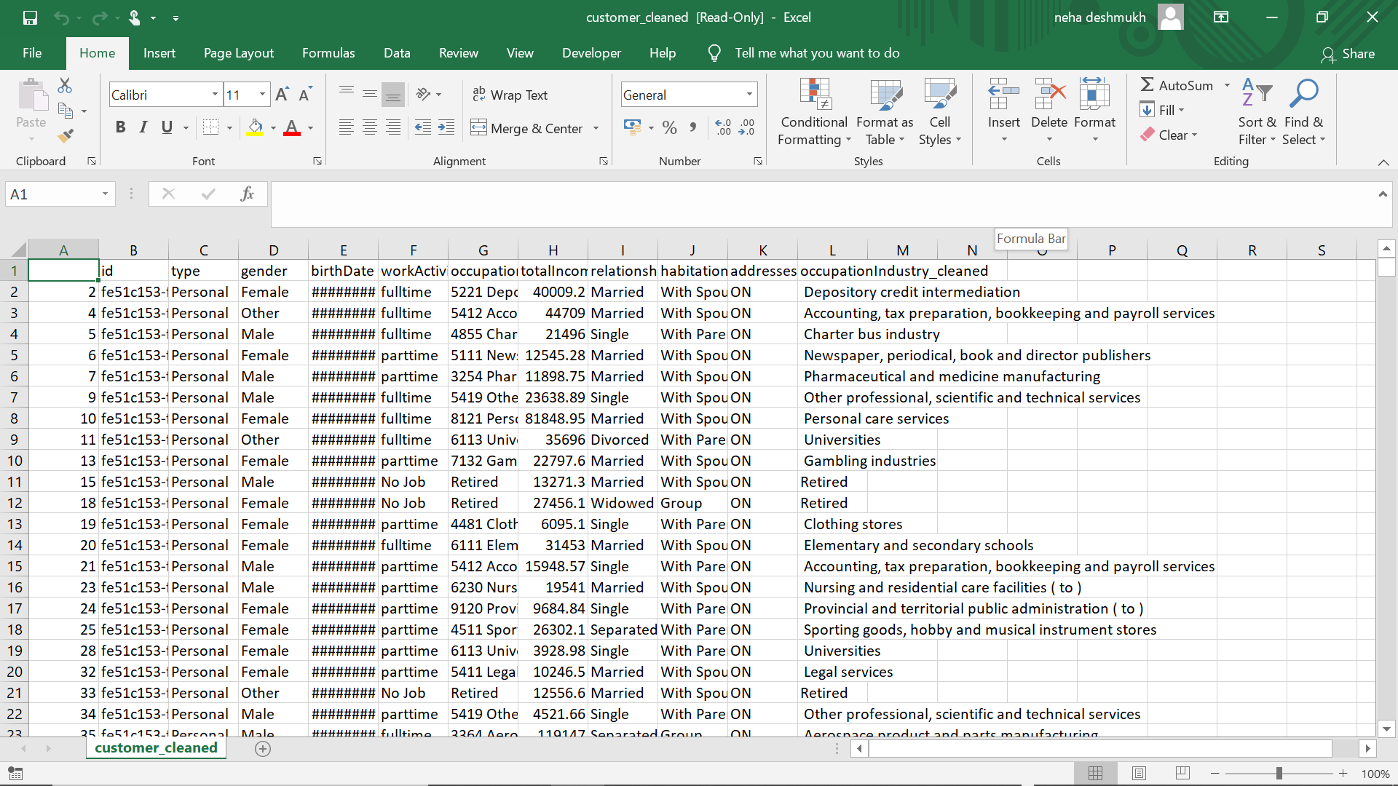

Transaction Data:

